Sustaining Our Safe and Compassionate Community
Living in the world is challenging right now. More than ever, we need the support of the Albany UU community in the search for truth and pursuit of justice. But in order to sustain this community we cherish, we need your help. It’s time for us to realize our commitment and intentions: in deeds, and words, and yes, in dollars. We hope that we can count you in as part of the 2017-18 Stewardship Campaign.
Consider which parts of our community are important to you: Is it…

- Music, thought-provoking messages, and the feeling of community with like-minded people at a Sunday morning service or at other discussion forums?
- The sense of belonging to a group that asks questions, encourages discussion and takes a stand on quality of life and justice issues that impact everyone, like Black Lives Matter, same-sex marriage, renewable energy, hydro fracking, climate change, and sustainability?
- Supporting youth who will carry our UU principles out into the world, by engaging them in programs that teach them to be more human, more compassionate, more sexually responsible, and better citizens?
- The encouragement and guidance for your personal journey through programs like Wellspring, Meaning Matters, Non-Violent Communication, Sunday Meditation, UU Humanists, All Sides Considered and other lifespan learning events?
- The support during times of personal illness or challenge, at milestones in your life - and having the opportunity to offer friendship and support to others
- Service to the greater community, whether by providing shelter meals, blankets, and winter clothes; volunteering at Sheridan Prep; building the Sheridan Prep playground; providing meeting space for many community groups; and supporting the FOCUS food pantries and other local non-profits?
- Giving voice to our shared progressive views by participating in demonstrations, lobbying at the Capitol, or writing letters to the editor?
If these aspects of our community are as important to you as they are to us, please consider becoming a “Visionary” as shown in the giving guide. Your pledge to Albany UU might just be one of the best investments you can make.
This year’s Campaign goal is $470,000, or 5% above what we raised last year. To reach this goal, we are asking you to raise your pledge if you can. As you decide on the amount you would like to give, think about what it would mean to increase your pledge. Determine your donor category and feel good about it. Personally, we felt glad when we increased our pledge and decided to give more. We hope you will feel the same.
When we reach this year’s Stewardship Goal, we will be able to continue our long history of serving our own Albany UU congregation while sharing our generosity with the greater community. We will continue fair compensation for our staff who serve Albany UU with great dedication, providing excellent worship, education and other programs for children, youth and adults. We will serve as a teaching congregation for our new ministerial intern, Eileen Casey-Campbell. And we will continue to advocate for justice, equity, compassion and protection of the interdependent web of all existence.

Please think deeply about how Albany UU provides a Sanctuary for you. It is a place of safety and security in a troubled world, a beacon of liberal religion in Albany. Thank you for your generosity and support.
Yours in service,
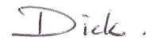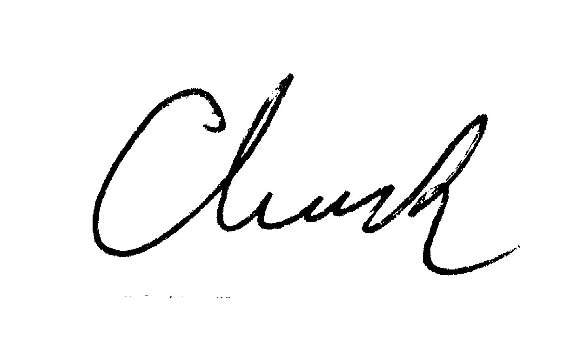
Dick Dana, President Chuck Manning, Stewardship Co-Chair Lynne Lekakis, Stewardship Co-Chair

