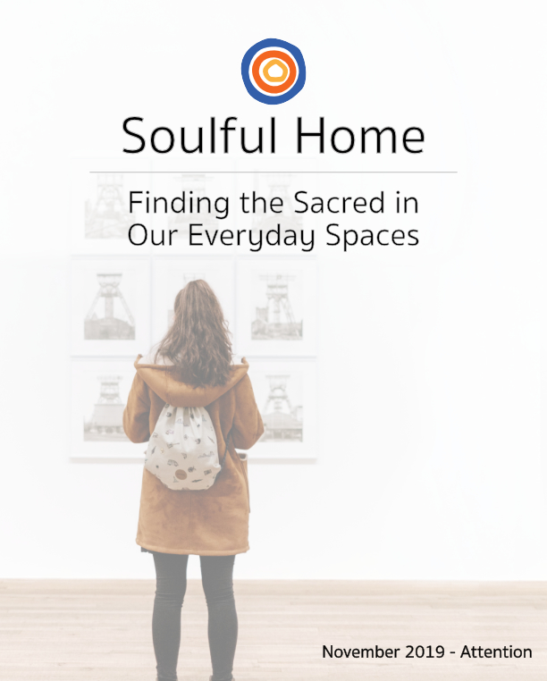

Table of Contents

The Welcome Mat: What does it mean to be a family of Attention
At the Table: Exploring Attention Through Discussion
Around the Neighborhood: A Treasure Hunt for Attention
At Play: Playing Games with Attention (Spot It!, I’m going on a trip…, and Attentive Taste Tests)
On the Message Board: A Monthly Mantra (“Where my attention flows, my energy goes.”)
At the Bedside: “The Wind and the Sun”: The “How” of Giving Our Attention
On the Porch: Raising a Child of Attention Together
The Extra Mile: Reaching out to youth climate activists, and Citizen Science for Birds
A Blessing of Attention

The Welcome Mat

What Does it Mean to be a Family of Attention?
My friend Sue, who is a writer now 87 years old, grew up under the rule, “Children are to be seen and not heard.” This rule, not uncommon even in our modern times, is deeply hurtful and confusing. It dismisses the value of children’s thoughts, ideas, and self-expression while harmfully increasing the degree to which they are attuned to the expectations of others. Sue describes being confused and hurt by this notion but said that it also made her a wonderfully attentive watcher. As an adult, when she was able to reclaim her voice, she had years and years of stories to tell, based on what she’d witnessed but not been allowed to express. It’s a great reminder that attention can be a very powerful mix of good and bad.
This month, we’ll be focusing on this power of attention. Our attention is a tool, a force, the means by which we consciously interact with the world.
In our At the Table section, we move back and forth between two facets of attention--getting it and giving it. In Around the Neighborhood, we pay special attention to our surroundings, looking for small treasures to collect and arrange as a centerpiece to focus attention wherever we gather. Our monthly mantra reclaims a deep truth from the world of hashtag wisdom. And the On the Porch section invites parenting partners to give one another the gift of focused attention as an act of love and support (for both giver and receiver).
We intentionally went out on a limb in our interpretation of the theme this month. You won’t find the word “mindful” in this packet, even though being mindful and paying attention are often used interchangeably, and we didn’t use any of Mary Oliver’s poetry, even though she was a master of paying attention and telling about it. Those facets of attention have been well covered in other places. Instead, we’re envisioning Attention as a tool that we can use, share, give, and receive with increasing grace, wisdom, and growing power. Because world-shapers and life-changers need to be able to focus, get to the heart of the matter, and do good work together.

At the Table

Exploring Attention Through Discussions
At the Table questions explore the monthly theme through a discussion with all ages. They are designed for a family gathering - maybe during a Friday night meal, a quiet moment in the living room or before a board game night.

Introducing the Activity

What might get your family’s attention in a fun way for these thought-provoking questions this month? Could you copy your five favorite questions onto slips of paper, put them in a hat, and pass them around? Write a few out on sticky notes and affix them to the chairs where you sit to eat? Take turns guessing numbers, one to 14, and then reading out those questions to answer together?
In our Around the Table family time, we want to find a way to experience both consistency and spontaneity, ritual and surprise. Try one of these new presentations or come up with your own to re-engage your family in rich, interesting discussions over meals.
- Who pays better attention? Adults or kids?
- Do you pay better attention when you are sitting quietly and listening or standing and moving around a little?
- Name something that you’ve done to get the attention of your parents or peers.*
- Have you ever been the person who draws attention to another person’s accomplishments, to lift them up and offer praise?
- Would you rather be the center of a group’s attention, or be among the crowd of observers?
- Who is someone whose style you admire, someone whose chosen look gets your attention in a positive way?
- What topic or subject always has your full attention, so that you never feel bored or unfocused?
- How do you know when your pet wants your attention?
- If you had the attention of the United States Congress or the Canadian Parliament for 5 minutes, like Swedish teenager Greta Thunberg did in October of 2019, what would you say to them?
- Sometimes, when our attention wanders, we actually come up with some pretty great ideas or realizations. Describe a recent daydream or wandering thought that was interesting to you
- What’s the best way to get the attention of trusted adults outside of your immediate family, if you needed their help?
- Advertisements and TV commercials use humor and surprise to get our attention. What’s a funny commercial that you’ve seen recently?
- How does it feel to you when you get attention that you DO NOT want, such as when you make a big mistake (or get loudly blamed for one!), or accidentally do something really noticeable?
- Art gets our attention by showing us something unique, moving, beautiful, unsettling, or keenly interesting. Name a piece of art that got your attention in one of these ways, or another, and if you can, find a picture of it to show your companions.

Discussion Support
Connection and acknowledgment are basic human needs. Asking for and receiving this kind of attention is seldom problematic. However, sometimes we crave not connection with others, but validation from them, because we struggle to feel as if we are enough in ourselves. This can lead to attention-seeking behaviors or actions that, later, we don’t feel good about. As you dig deeper into this question, try to distinguish between these two types of “getting attention,” the kind that reminds us who and whose we are, and the kind that takes us farther from that authenticity and connection.
And parents, if you’re up for some wider-ranging thoughts on this topic, check out American actor Jason Gordon Levitt’s TED talk on the subject: https://www.ted.com/talks/joseph_gordon_levitt_how_craving_attention_makes_you_less_creative?language=en

Ways to Return to the Discussion Throughout the Week

Thoughts develop with time. Find opportunities to bring up particularly compelling questions again during the month, maybe on walks, rides home, when tucking your child in to bed, etc. If thoughts grew or changed, notice that together, how we are all evolving beings, opening ourselves to new truths and understandings as we live our lives and connect with others.

Around the Neighborhood

A Treasure Hunt for Attention: A Collection of What Catches our Eye
Around the Neighborhood activities engage families with their surroundings through the lens of the theme. It’s about perceiving your well-known world in new ways Take our monthly treasure hunt list with you on your trips to the grocery, walks around the neighborhood or bike rides, and transform your everyday travel into a family adventure.

Introducing the Activity

This month is a different sort of treasure hunt. We’re going to pay special attention to the things that “catch our eye.” When walking around or playing in our neighborhoods, little things naturally grab our attention: rocks, seedpods, sticks, flowers dried on their stalks, interesting cast-off do-dads, an old coin or a broken piece of pottery, etc.. Most often, we walk right past them there in the path, or on the street, or in the park. But for this month, we’re going to start a temporary collection as a way to hold these little gifts of paying attention, to be extra grateful for the ways our world surprises us with tiny treasures.

When each person in the family has an object, we’ll create a centerpiece together wherever we most often gather. This might be a table around which you eat, but it might also be the spot in the kitchen where folks hang out to keep the cook company and chat, or a coffee table in the room where people flop at the end of the day to touch base.

Begin with some sort of decorative cloth in a color you all like--a lightweight scarf works well for this, and thrift stores often have oodles of them. This is going to be the base for your other objects. Next, do you have a chalice? If so, place it in the center of your cloth. If not, a votive candle or similar will do nicely.

Go out in your neighborhood each week of the month to seek out an addition to your family centerpiece. But remember, each person can only have one to three objects in the centerpiece at once, so you may need to switch out items as new things catch your eye.

When you gather, let your attention linger for a moment on your creation. Then, light your chalice, and enjoy your family time.

Reflection
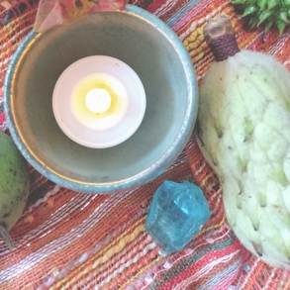
Most of us would say that a long-term goal is to spend more quality time together as a family. The activity uses the science of small wins to create momentum and joy around that goal. By successfully focusing our attention on our family creativity, cooperation, and conviviality, we are communicating to ourselves that greater family time is achievable.

At Play

Playing Games with Attention
At Play activities and questions are a way to joyfully, playfully, and imaginatively experience the theme. We offer a brief framework to introduce the game and another to reflect upon it, so that the insights learned in play can stay with us throughout the month and beyond.
Option A: Spot It!
Who in your family can focus their attention the fastest? This game will help you find out!
Spot It! is a fun and fast-paced, all-ages family game that you can find at most major retailers for around $10. The point of the game is to find the matching pictures on the circular cards. The trick is that when the picture placement and size is changed, our brains have a harder time recognizing it, so this game calls for extreme focus of attention.
There’s some interesting math behind the matching, too, which Smithsonian Magazine describes here:
https://www.smithsonianmag.com/science-nature/math-card-game-spot-it-180970873/
Note: Spot It! is small enough to stash in the car or in a bag to have handy when you find yourself waiting unexpectedly with antsy kids. You can easily pull attention toward a fun game and away from the frustration of waiting!

Option B: Radish Revelations and Potato Chip Meditations
Well-known Buddhist author and chef Edward Espe Brown wrote in 1997 about a potato chip meditation, a guided activity where participants attuned to the experience of eating one, single potato chip. It was a somewhat tongue-in-cheek activity for him initially, but people responded well to it, describing new insights into the sensory experience of eating simply by paying exquisite attention.
This month, we'll playfully recreate something similar, but as a guessing game. Acquire a few seasonal but uncommon fresh food, or prepared foods in brands or flavors you don't normally buy. (Chestnuts? A new kind of radish? What's unusual for your family's food culture?) Make up a plate for each member of the family with three to five of these new foods, and taste them one at a time, together, describing your experience as you go. Linger! Pay attention! Savor! Then, the person who can guess the most foods or ingredients wins!
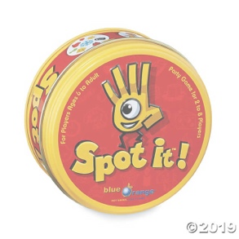

Option C: I’m going on a trip, and I’m bringing...
This game gives us the chance to give and receive attention in equal measure--we’ll be playing off of one another’s contributions to create the longest string of remembered items we can.
“I’m going on a trip…” is often played as a car game to pass the time. The first player begins by completing the sentence, “I am going on a trip, and I’m bringing ________.” The next player also completes that sentence but adds the first player’s item to their own. “I’m going on a trip, and I’m bringing socks.” “I’m going on a trip, and I’m bringing socks and a ladybug.” “I’m going on a trip, and I’m bringing socks, a ladybug, and an ice cube,” and so on. This continues among players until one player forgets an item in the string.
Common variations are to use the alphabet to add items, with the first item starting with A, second one, B, and proceeding through all 26 letters. Another variation is to use numbers: “The number on my mind is 5.” “The number on my mind is 5-2.” “The number on my mind is “5-2-4,” etc.
This game relies on our paying attention--listening, making mental pictures about what we hear, and finding patterns in the group of objects. While it’s a fun challenge, and those mental images can be silly, these same skills are important for learning and developing the ability to focus and remember information.

On the Message Board

A Monthly Mantra

The On the Message Board section lifts up a theme-related mantra for your family to carry with them throughout the month. Think of these “family sayings” as tools for the journey, reminders that help us refocus and steady ourselves and our kids as we navigate through life’s challenges and opportunities. Write them on sticky notes to put in your car, on kitchen cabinet fronts, in lunch boxes, on computer screens and, of course, on your family message board. Share them out loud at home and out in the world, where and whenever the need arises.

November’s Mantra
“Where my attention goes, my energy flows.”
This mantra comes from internet meme culture. Sometimes these pithy sayings are easy to gloss over. We think this one deserves our attention.
We live in overwhelming times, at the smallest and grandest levels. Our children face petty dismissals that sting, microaggressions that wear away at their confidence, disappointments from trusted peers and adults, and unrealistic expectations about how their attention should be spent in school and other spaces, not to mention humongous topics that seem to cast shadows over everything--climate change, news about elected officials’ newest moves that erode democracy and human rights.
“Where my attention goes, my energy flows” attempts to move our children (and us parents) from despair, nihilism, and resentment toward empowerment and tactical problem-solving, through the power of our attention.
If a big conversation comes up in your home--something that can easily become overwhelming, like climate change--you might take a few quiet breaths with your child, and affirm that fear, sadness, and hopelessness are all understandable reactions to that issue. And when it feels right to pivot the conversation, try beginning with the mantra, and then seeing together what positive actions are happening in your community and in our world that you’d like to put energy toward. The energy can be a simple as a prayer or positive thought, or could be putting an action item on your family calendar (call local climate action group, see if you can arrange a tree-planting on church property, write a letter to one of the many youth climate activists in the U.S. and beyond--see the Extra Mile for help with this one!).
There is power in our attention. Let’s all remember to channel it in the service of change in ourselves, our communities,, and our beautiful, deeply beloved world.

At the Bedside
The Bedside activities engage the theme through storytelling. This takes place during the dreamy, almost otherworldly hour or so before children or youth drift off to sleep. Through stories and the questions and realizations that they prompt, we come to understand the nature of and our own place in the cosmos. But also, these selections invite you to remember, shape, and share stories from your own past, using thoughtful narratives to help your child weave the tale of who they are and whose they are.

The Wind and the Sun:

Using Attention to Get Things Done

“The Wind and the Sun” is one of ancient Greek storyteller Aesop’s fables, teaching stories that feature non-human characters. It was collected and published by Unitarian Universalist faith development for parent, Sophia Fahs, in her book From Long Ago and Many Lands. The entire book is published online here, through the UUA, and our story is on page 59.
With three, simple characters: the sun, the wind, and a man wearing a coat, this story is a good candidate for using props, stick puppets, or construction paper headband costumes. Younger children will enjoy this visual addition to storytelling, and older children might get a giggle out of it and humor their parent or guardian!
This story is usually told with a focus on a message such as, “You get better results working with people versus working against them.” (Like the expression, “You attract more bees with honey.”) But like all good stories, this one has many meanings, and with our focus on attention, the message might be summarized as, “Assess your situation, and decide how best to attend to it.” We make many choices about how to use our witness, our voices, and our actions when confronted with a challenge, and this story makes the power of that choice more explicit.
Here’s an animated video for the story, for you to watch later in the month after the bedside telling the story:
https://www.youtube.com/watch?v=51_FHblK4mc

Some Questions to Consider Afterward:
- The sun and the wind both used their focused attention to try and get something done. How would you describe the different ways they approached their task?
- When you want to convince someone of something--a friend, a teacher, your parent or guardian--how do you bring it up? What are your most effective tactics?
- Sometimes, using forceful, powerful, gusting words and actions are called for. What do you feel so strongly about that you want to bluster and blow and howl?
- Parents and guardians, tell about a time that you used gentle kindness and connection to get a need met, or get an important point across, and tell about a time that you used powerful words and actions to do it. Be ready to share how each of these approaches felt to use. And share what these instances taught you about the ways you use your energy and attention in the world.
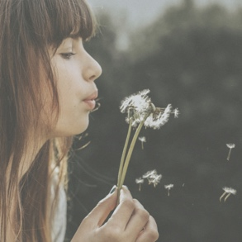

On the Porch

Raising a Child of Attention Together
On the Porch supports sharing realizations, challenges and hopes around the theme with other supportive adults. It connects parents with their co-parents, with their close circle of supporters, with extended family or whomever they turn to for love and fellowship. Perhaps this happens on a literal porch or front stoop, but it could happen wherever parents and their circle of support gather and talk over the soulful parts of parenthood.

A Sip of Something More

Author and activist Parker Palmer talks about the value of bringing a “third thing” into conversations among partners or small groups--words, pictures, music, etc. that can act as catalysts for deeper sharing. We present that idea as “a sip of something more,” a monthly source of nourishment that tantalizes and brings to mind a new insight, memory, or feeling. So as you head to the porch with your parenting companion, don’t bring just your usual cup of coffee or tea; also take with you this additional “conversation partner”:

Taking Turns Giving Full Attention:
What’s going on for you right now?

Suggested Structure: This is a deceptively simple exercise. What you’re going to do is give your conversation partner your full, undivided attention for five minutes, and you’ll set a timer. Then, you’ll switch. Practicing offering the gift of our whole selves is one way we can show care and affection for our parenting partners.
You begin by asking your partner, “What’s going on for you right now?” And then, tune in. Your mind might wander as the other person speaks. Gently bring it back. You may notice that your foot is tapping on the floor, or your face is tensing up as you hear something you didn’t like. Gently bring your body back into neutrality. A dozen other impulses, almost subconscious actions, thoughts, or desires may arise. Let them all pass. The gift you are giving the speaker is your full attention so that they may release some of their burdens and make more room in their own soulful space. Be as open and receptive as you can be for five minutes.
- When the speaker has finished, if the full five minutes isn’t up, stay in silence together until your timer rings.
- When the timer rings, take an extra moment to ready yourselves to switch places.
- When you’re both ready, switch so that the listener is now speaking.
- When both of you have had a chance to share and listen, reflect to one another how it was to give and receive that kind of focused attention.

Note: At the end of the At the Table section, we linked to a TED talk from Jason Gordon Levitt in which he describes the powerful shift between seeing others as competitors (people who get more attention than you) and seeing them as collaborators (people to whom you pay attention with the intention of working together more creatively and effectively). As you practice giving and receiving undivided attention to and from your parenting partners, let your mind wander to ways that you and this special person are working well together already, and imagine ways you might make your partnership more creative and effective in the future.

Spiritual Snacks to Share
In addition to your “third thing,” bring one or two of these questions with you when the time comes to hang out with your co-parent or buddies. Don’t treat the questions as a list to go through one by one. Instead pick the one or two that speak to you the most, seeing them as your inner voice inviting you to lean into attention more deeply in your living and loving.

- How have you experienced your attention span changing as you’ve aged?
- To whom or what would you give your attention if you had an extra hour of the day, at a time of your choosing?
- What took up a lot of your attention this month that you feel was a waste of time? What was the worthiest focus of your attention this month?
- When growing up, what one thing above all others did your family tell you was worthy of attention? Beauty? Status? Duty? Kindness? Honesty? Education? Loyalty? Success? God?
- What in your life is hungry to be noticed?

The Extra Mile

The Extra Mile section is for families who want to continue exploring the theme of the month through larger adventures, more complex projects or simply through additional modalities not otherwise included in the packets. The Extra Mile suggestions often surpass what is considered an “everyday moment” in a family, and may involve more preparation, planning, or time to accomplish. A bit more effort, but well worth it!

Giving Attention to Youth Climate Activists
Youth climate activists have been getting a lot of deserved media for their courage, commitment, and clarity on the issues of climate crisis. If your family is doing similar work in your community that you want to share, or you want to express your appreciation to one or more of these youth for doing this critical work, consider sending an email to an activist who represents your state with the Youth Climate Strike organization, or following and then tagging an activist whose work you admire, and learning about youth climate activists whose efforts haven’t received the same attention as other activists because of our white supremacy culture.

Attention to the Birds
November of each year begins a very special six-month citizen-science endeavor called Project Feederwatch. Jointly sponsored by the Cornell Lab of Ornithology and Bird Studies Canada, the project empowers households across the continent to use their own yards to contribute vital data about North American birds, a task that is more crucial now than ever in our era of mass species extinction.
To get started, you sign up here, and pay your $18, which covers the staff and administration fees, but also your kit, a poster, and a bird-themed calendar for the following year. Then, you need
- a bird feeder (in years past, my family has used things as simple as aluminum pie plates tacked to a wooden handrail, though of course there are dozens of styles of feeders you can make or purchase, too),
- or a bird bath,
- or a native plant that attracts birds to your yard.
Then, you set a schedule for you and your family to sit and watch the birds, choosing an amount of time and frequency of watching that suits you. And finally, you submit your data.
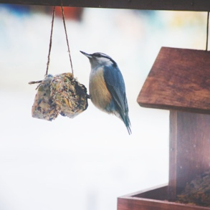
It seems so simple, but by empowering thousands and thousands of households to complete this task over the past two decades, Project Feederwatch has created an unparalleled data set that has allowed scientists to observe trends in bird populations that they never would have been able to spot alone. And the real beauty for families is that you have a very lovely, and also entertaining, focus of your attention together--the birds that share your little bioregion, or visit it for a short while on migration. You’ll learn their names, their sounds, their behaviors, the way their coloring changes over the season, and you may even be able to pick out individual birds who nest near your home, visiting your feeder several times a day! It’s a precious and useful way to gather in cheerful quiet, strengthening our join on the interconnected web of all existence.

Blessing of Attention

May your eyes stumble on the astonishing,
may your ears catch snatches of joy,
may your fingers find pleasure in texture and touch,
may deliciousness dance on your tongue,
and may the fragrance of this good earth lure you in a new direction,
transporting you from distraction to full attention,
from doubt and worry to the here and now,
where you are loved,
needed,
wanted,
and best of all, alive.
Blessed be the wonders all around you,
and blessed be the treasure that is you, dear one,
so, so worthy of love and attention.

More Inspiration for your family, and you…

Join our Facebook and Instagram pages for
daily inspiration on our themes:
Facebook: https://www.facebook.com/soulmatterssharingcircle/?ref=settings
Instagram: https://www.instagram.com/soul_matters_circle/

Check out our Spotify Playlist for Attention at:
https://open.spotify.com/playlist/77GATwAL7L9YmcSe1rUAvL?si=vu-f5uQUSG2umUUQM89y9w

Soulful Home packets are prepared by
Teresa Honey Youngblood,
Our Soul Matters Family Ministry Coordinator

Learn more about subscribing
to these monthly resource packets on our website:
https://www.soulmatterssharingcircle.com/soulful-home.html

© 2019-20 Soul Matters ALL RIGHTS RESERVED

Packets are for use only by member congregations of and individual subscribers
to the Soul Matters Sharing Circle.
Learn how to join at http://www.soulmatterssharingcircle.com

